* PYTHON CHEATSHEET🚨 FOR JOB INTERVIEWS📝*

**1. Functions: Define and Use Functions**

**Explanation:** Defines a reusable function to greet a user and demonstrates its use.

**Code Example:**

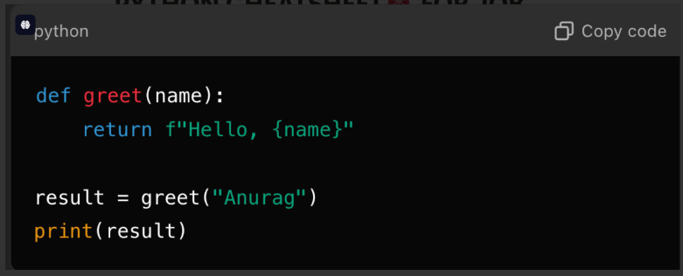

**2. Lists: Basic Operations on Lists**

**Explanation:** Shows how to add, remove, and manipulate elements in a list.

**Code Example:**

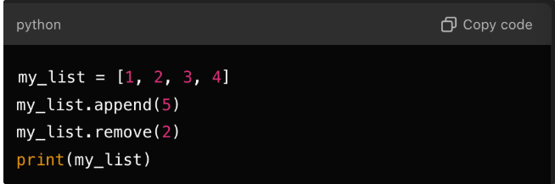

**3. Loops: Iterating Over Lists**

**Explanation:** Iterates over a list and prints each item.

**Code Example:**

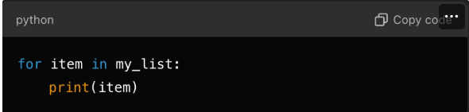

**4. File Handling: Read and Write Files**

**Explanation:** Demonstrates writing to and reading from a text file using the 'with' statement.

**Code Example:**

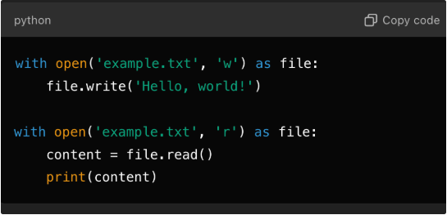

**5. Data Manipulation with Dictionaries**

**Explanation:** Adds and accesses elements in a dictionary, demonstrating data manipulation.

**Code Example:**

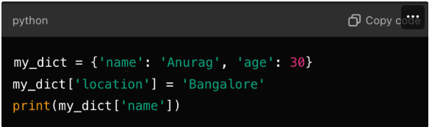

**6. List Comprehensions**

**Explanation: Creates a list of squares using list comprehension.**

**Code Example:**

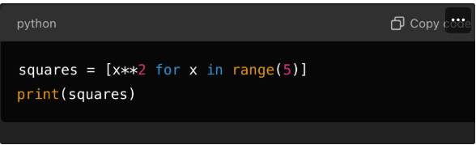

**7. Exception Handling**

**Explanation: Handles division by zero error using a try-except block.**

**Code Example:**

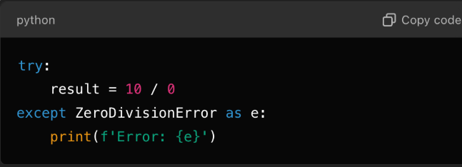

**8. Reading CSV Files**

**Explanation: Reads and prints rows from a CSV file using the csv module.**

**Code Example:**

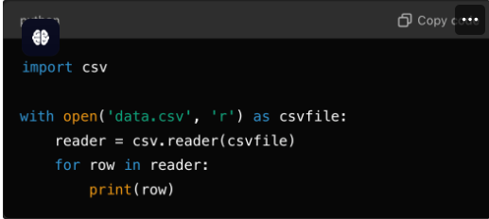

**9. Writing JSON Data**

**Explanation: Writes a dictionary to a JSON file using the json module.**

**Code Example:**

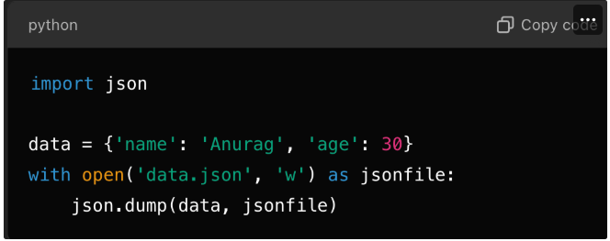

**10. Pandas: DataFrame Basics**

**Explanation: Creates a simple Pandas DataFrame and prints it.**

**Code Example:**

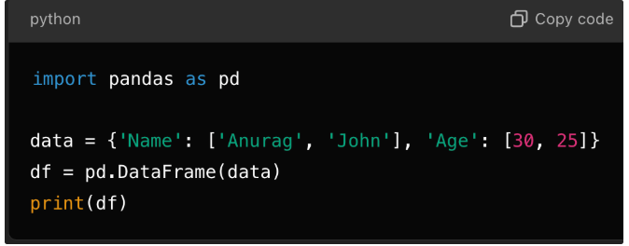

**PRACTICAL QUESTIONS FOR INTERVIEWS**

**1. Reverse a String Without Using Built-in Functions**

**Question:**

How would you reverse a string in Python without using built-in slicing or reverse functions?

**Answer:**

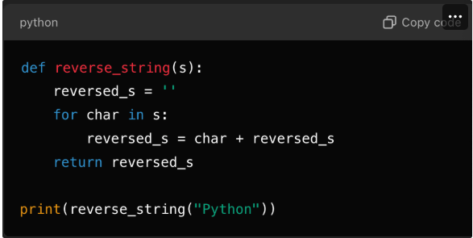

**2. Check if Two Strings are Anagrams**

**Question:**

**Write a function to check if two strings are anagrams of each other.**

**Answer:**

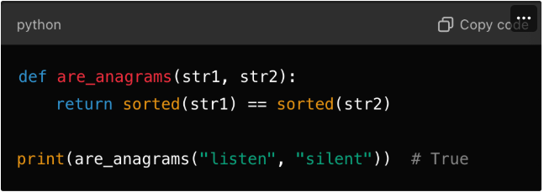

**3. Find the Missing Number in a List**

**Question:**

**Given a list of integers from 1 to n with one number missing, find the missing number.**

**Answer:**

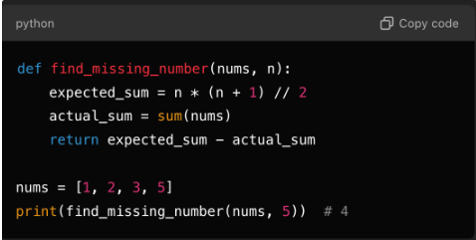

**4. Flatten a Nested List**

**Question:**

Write a function to flatten a nested list.

**Answer:**

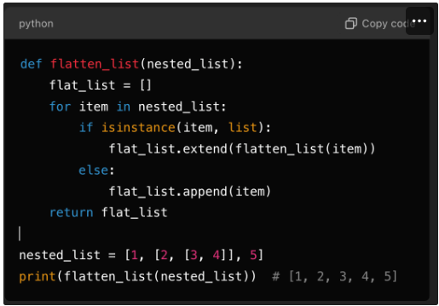

**5. Implement a Simple Cache (Memoization)**

**Question:**

Write a function to cache the results of expensive computations.

**Answer:**

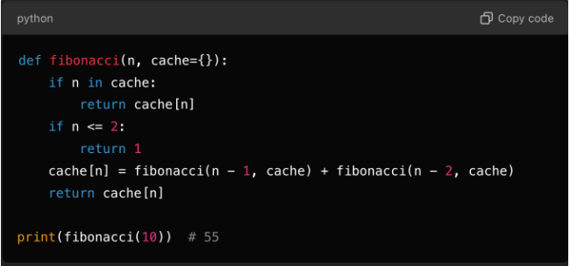

**6. Find the First Non-Repeating Character**

**Question:**

Write a function to find the first non-repeating character in a string.

**Answer:**

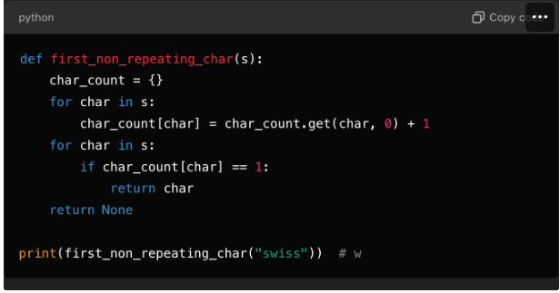

**7. Sort a Dictionary by Its Values**

**Question:**

How would you sort a dictionary by its values?

**Answer:**

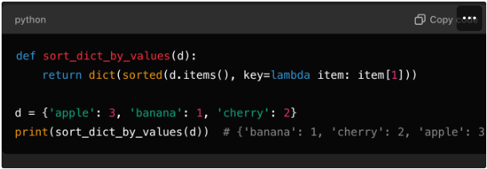

**8. Find the Longest Palindromic Substring**

**Question:**

Write a function to find the longest palindromic substring in a given string.

**Answer:**

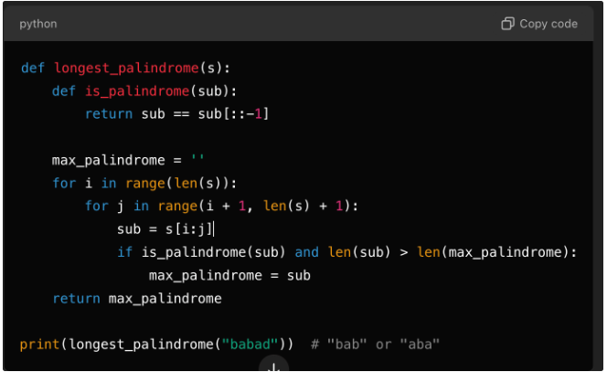

**9. Count the Frequency of Words in a String**

**Question:**

Write a function to count the frequency of each word in a string.

**Answer:**

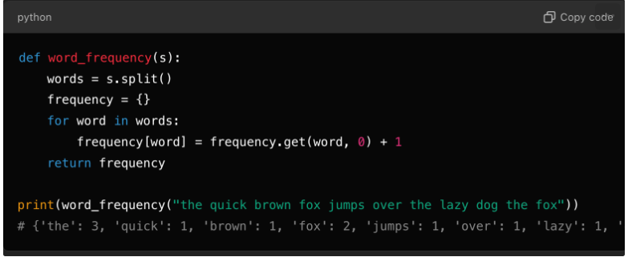

**10. Generate All Permutations of a List**

**Question:**

Write a function to generate all permutations of a list.

**Answer:**

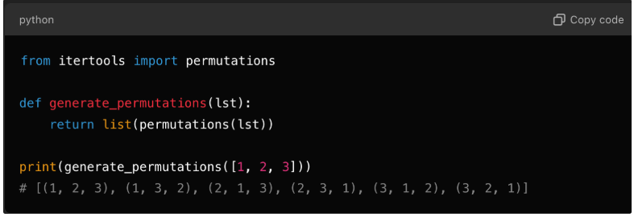

----------------------------------------------------------END---------------------------------------------------------------------